LANGUAGE ARTS 7
Wilson Middle School
2017/2018

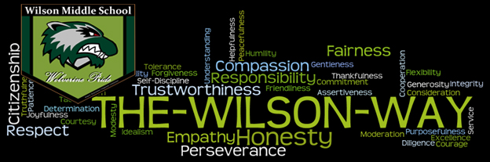

“It takes courage to grow up and become who you really are.”
- E.E. Cummings

Overview:
The aim of Language Arts is to enable each student to understand and appreciate language, and to use it confidently and competently in a variety of situations for communication, personal satisfaction, and learning. To achieve this, students will use the six Language Arts strands, which include listening, speaking, reading, writing, viewing, and representing. These six strands will allow students to:

- Explore thoughts, feelings, ideas, and experiences to comprehend literature
- Respond personally, critically, and creatively to various texts
- Manage ideas and information
- Create oral, print, visual, and multimedia texts
- Enhance the clarity and artistry of communication
- Respect, support, and collaborate with others

Course Content:
For the duration of the school year, this Language Arts course will explore a variety of texts including novels, short stories, films, poetry, and media literacy. Students will gain valuable skills by responding to texts in a variety of forms that are balanced around the six strands of Language Arts. Spelling, Vocabulary, Grammar will also be components. In addition, students will produce many different kinds of writing assignments – expository paragraphs, descriptive writing, persuasive writing, personal narrative writing, letter writing, informational reports, and short stories.

What to Bring to Class:
- Binder
- Pencil Case with pencils, pens, an eraser, ruler, highlighter
- Self- selected reading materials (this can be a magazine, ebook, graphic novel, newspaper, journal, and of course, novels!)

Student Expectations:

- Treat everyone in the classroom with respect
- Have a willingness to work to the best of your ability
- Come to class prepared with your supplies
- Arrive to class on time
- Use class time effectively; get started right away
- Be responsible for your learning
- Participate in class discussions
- Cooperate with others

Evaluation:

Over the course of the school year there will be three trimesters. Grades will be calculated cumulatively. Cumulative grading means that as each assignment, project, or quiz is added on to a student’s record, the overall average and final mark is adjusted. With cumulative grading, there are no calculations of averages from reporting periods 1-3. The course work that you complete will make up 80% of your overall grade. The final exam will make up 20% of your overall grade.

Semester Work 80%

Written Work 32%
Reading Assignments 32%
Spelling, Grammar, Vocabulary Quizzes 16%

Final Exam –
Part A: Written (4 paragraphs: descriptive, expository, persuasive, narrative) 10%
Part B: Reading Comprehension Multiple Choice 10%

Total: 100%

If you have any questions, please contact me!

Sincerely,

Miss Caitlin Mitchell

