ABORIGINAL SOCIETIES

Who are the diverse Aboriginal peoples who have contributed to the building of the country we now call Canada?

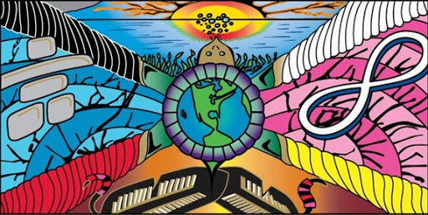

NAME:_______________________________

7.1.3: Students will compare and contrast diverse social and economic structures within the societies of Aboriginal, French and British peoples in pre-Confederation Canada by exploring and reflecting upon the following questions and issues:
- What were the different ways in which Aboriginal societies were structured (i.e., Iroquois Confederacy, Ojibwa, Mi’kmaq)?

- How did the structures of Aboriginal societies affect decision making in each society (i.e., role an status of women, consensus building)?

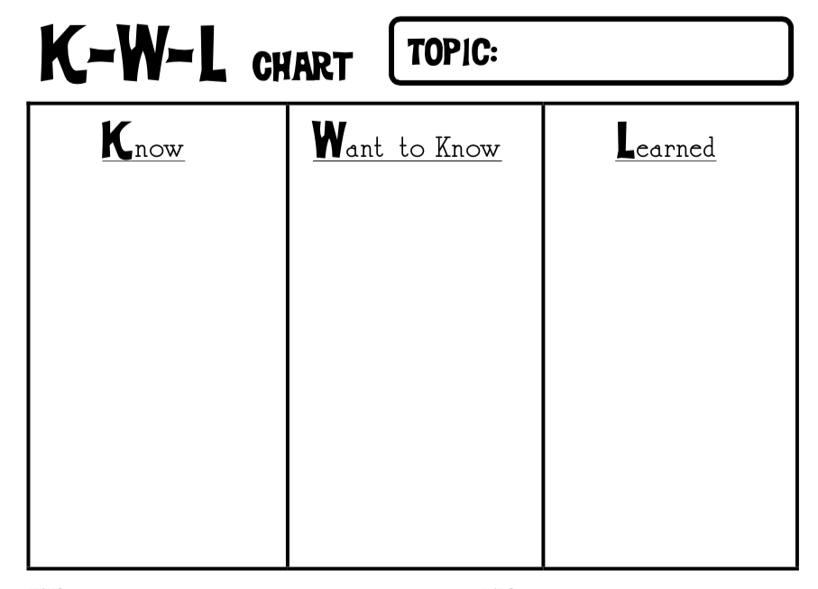

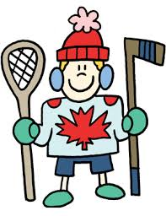
Culture

What does culture include?
_____________, ______________, & ___________ that a group shares and that shape the way its members see the world. _________________, ____________________ with nature, ________________ and _________________.

Explain and defend why you chose to represent Canadian culture with the symbols on your newly designed $20 bill:___________________________________________
____________________________________________________________________________________________________________________________________________________________________________________________________________________________________________________________________________________________________________________________________________________________________________________________________________________________________________________________________________________________________________________________________________________________________________________________________________________________________________________________________________________________________________________________________________________________________________________________________________________________________________________________
__________________________________________________________________________________________________________________________________________
__________________________________________________________________________________________________________________________________________
__________________________________________________________________________________________________________________________________________
__________________________________________________________________________________________________________________________________________
__________________________________________________________________________________________________________________________________________
__________________________________________________________________________________________________________________________________________
__________________________________________________________________________________________________________________________________________

Textbook: Page 4-7
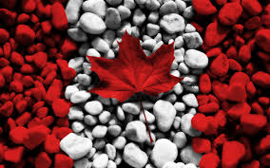
PLURALISTIC SOCIETIES:

Pluralistic society means that our __________________ has helped us to value all ___________________. We are a society made up of many ______________ of people. All these groups have unique________________, ideas, _________________ and ways of seeing the ___________________. Individual members within each group have their own points of _______________ and _____________________, which may be different from those of other _____________________.

Primary Source Image:

Secondary Source Image:

Values & Viewpoints:

- First Nations peoples have lived in all parts of the land we now call Canada. Each First Nation developed a ______________culture suited to its surroundings in the natural world. The peoples’ cultures became as diverse as the Canadian landscape. (Map page 7)

- Diverse peoples can also share core values. Taken together, these values make up a __________________.

- First Nations peoples are indigenous to North America. Beliefs are often passed from generation to generation through _________________________. These teachings are passed down orally by Elders. This is why First Nations peoples developed a rich oral culture.

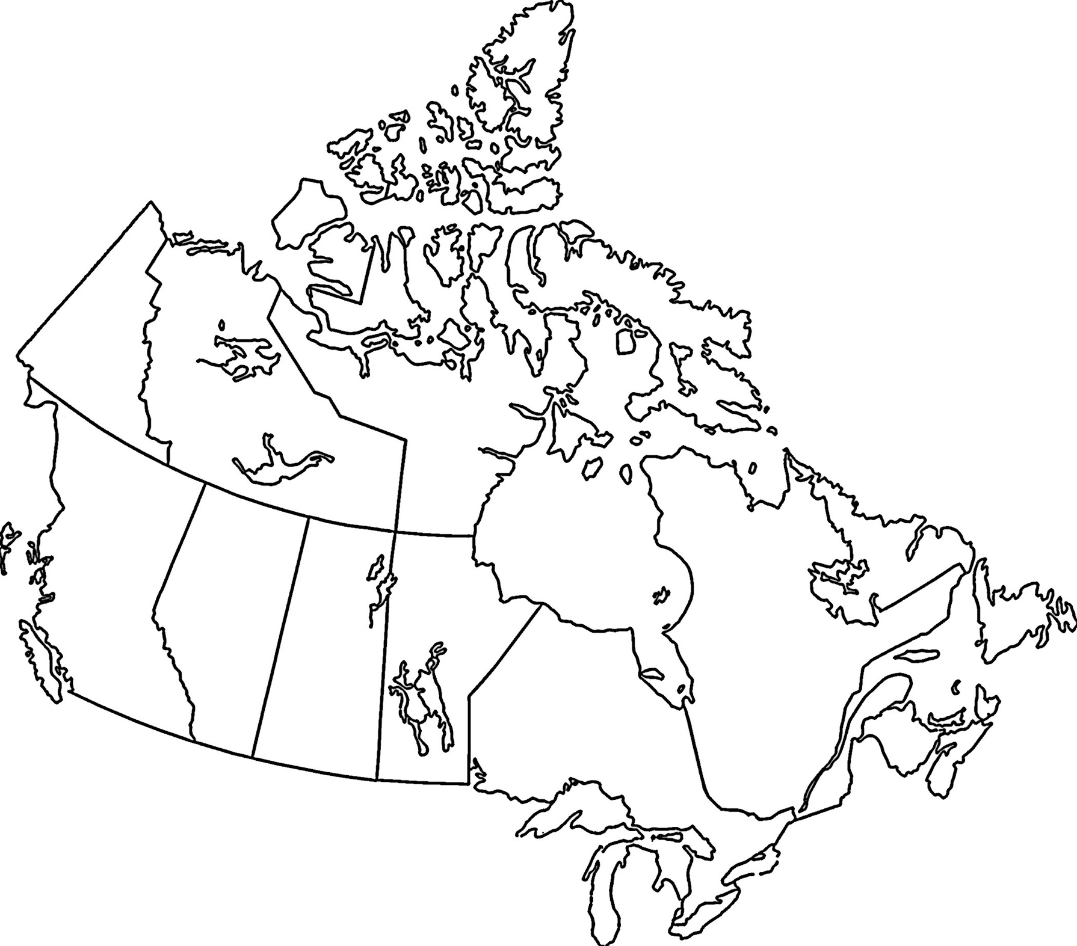

Compare & contrast social/economic structures within these 3 aboriginal societies of pre-Confederation Canada

MI’KMAQ  (MIG-mah) | HAUDENOSAUNEE  (Hah-duh-nuh-SAH-nee) | ANISHINABE  (a-nih-shih-NAH-bee)
Where Did They Live?  Hunters, Fishers and Gatherers: | Where Did They Live?  Farmers: | Where Did They Live?  Hunter –Gatherers:  (Wild Rice Harvesters)
MI’KMAQ | HAUDENOSAUNEE | ANISHINABE
Clans:  Food: | Three Sisters:  Other Crops: | Hunter-Gatherers (cont’d):
MI’KMAQ | HAUDENOSAUNEE | ANISHINABE
Connection to Nature:  Government: | Sharing Work & Rewards:  Government: | Worldview:  Government:
MI’KMAQ | HAUDENOSAUNEE | ANISHINABE
Decision Making:  Role of Women: | Decision Making:  Role of Women: | Decision Making:  Role of Women:

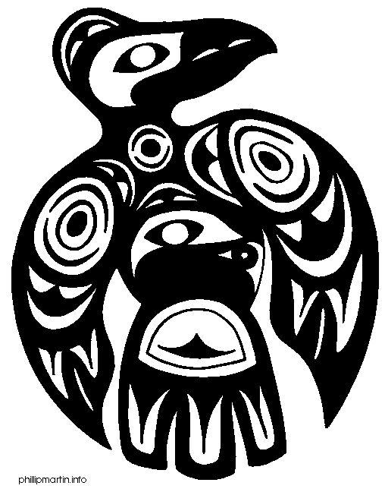
ECONOMY & RESOURCES: Fill in the blanks using information found on pages 26-28.

First Nations’ economies differed according to resources available to them. The economies of the First Nations were based on ____________________ supply. If resources were scarce, people spent most their time _________________ food. If there was plenty of food available, people had time to spend on other things, such as art and ______________________.

In hunter-gather societies, people gathered __________________, __________________, and fished according to the _________________. Most of the food was eaten fresh, but some was _________________ and stored to eat during the winter. People had to know about the land, climate and the cycles of ___________________ in order for this economy to work. Hunter-gathers moved their camps as the seasons and _________________ supply changed. They didn’t gather many extra goods because they had to ________________ around so much. Their focus was not on trading, but more on being in rhythm with the _______________ and nature.

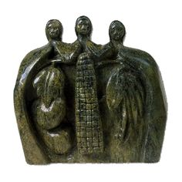
Farming economies developed where _______________ & ____________________ were ideal for growing crops. Farming DID NOT move around as hunter-gatherers did. Farming societies could often grow ____________ food than the people needed so less time had to be spent hunting and gathering. People had more time for creating _______________, performing _________________ and __________________. The extras could also be used for ________________ with other groups.

Trading Networks: name several products that the first Nations people traded: ____________________________________________________________
______________________________________________________________________________________________________________________________________________________________________________________________________.

When did First Nations start trading?

