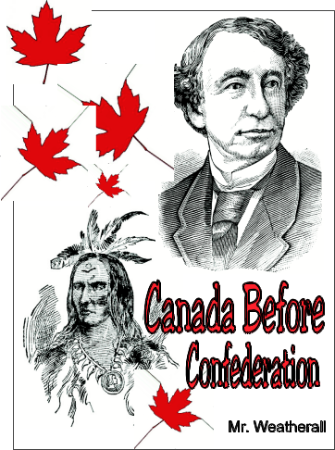
Part 1: Canada Before Confederation
Title Page Assignment

You will design a title page for the first part of our studies of Canadian History. Your title page should be well thought out and visually explain what this unit is about and the information that it covers. Use the 22.5 cm X 28cm paper provided.

Include the following in the design of your title page:

- Your title page should have the title of this unit on it and it should play a prominent role in the design in both size, colour and position.
- It is preferred that you draw or cut pictures from a magazine, but you could print from the internet, pictures that are representative of the contents and ideas covered in this unit and the idea of Canada. Things like first nations people, canoe, beaver, maple leafs.
- Include the time frame that this unit covers, refer to the time line on pages 2 & 3 of the text.
- Colour and design are essential elements and should be utilized at all times. Remember this should be treated as though it were the cover to a book and be interesting to look at.
- Include a border, complete with design elements.
- Include the use of stencils and or fonts from your computer.
- Include your name, and class pattern (first and last) in the lower right hand side of the page.
- Be careful and make sure the holes of the page are on the left hand side of the page.

Canada Before Confederation Title Page Assignment – Marking Criteria
Criteria | Excellent | Very Good | Adequate | Limited | Total
Required Information | The title page includes all of the required information as well as additional information | All required information is included on the title page. | All but one part of the information is included on the title page. | Several parts of the information have not been included on the title page. | 4
Pictures | The pictures used on the title page reflect an exceptional degree of student creativity and utilize careful, neat work and are original | One or more of the pictures used on the title page reflect a degree of student creativity in their creation and are generally well done. | The pictures are made by the student, but are not done with much effort or care. | No pictures are included on any part of the title page. | 3
Content Accuracy | All important facts are represented and explain the unit that is being covered. | There are one or two inaccuracies that have incorrect information or are not appropriate to the unit. | Much of the content is incorrect information or are not poorly explained. | Little or no effort was made to include accurate information and to explain it. | 1
Mechanics & Sentence Structure | Capitalization, punctuation and are correct throughout the assignment.  All elements are included. | There are one or two errors in capitalization, punctuation, and sentence structure. Most of the required elements are present. | There are several errors in capitalization, punctuation and sentence structure. Only some of the required elements are present | Little effort was made to correct capitalization and sentence structure. Few of the required elements are included. | 2
Total |  |  |  |  | 10

