A Picture Is Worth A Thousand Words: Buffalo Skin Project

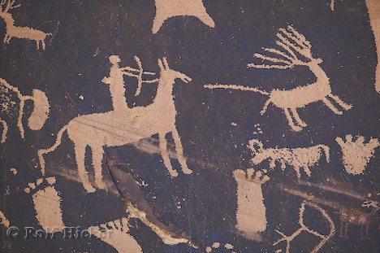
They say that a picture is worth a thousand words. Many of the things we know about various the First Nations people have been learned by studying their artwork. Your assignment is to create a buffalo skin that will show how First Nations people lived hundreds of years ago.

You will create a pictorial scene on a buffalo skin to show the way of life the First Nations groups Mi’kmaq, Haudenosaunee, and Anishiniabe and how they lived before the arrival of the Europeans. The information you need can be found in the textbook in Chapter One. Imagine that your artwork will hang in a Museum hundreds of years later and be used to tell the story of these First Nations People.
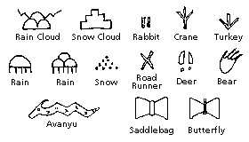
You will be graded according to how well you demonstrate an understanding of the following concepts.

- How did the First Nation people meet their physical needs- food, clothing, shelter
- What beliefs and values did the societies focus on?
- How did the groups form and run their government? Can you show how decisions were made?
- What was the groups connection with Nature?
- Did all people have a role? Focus on the role of women.
- What products was the basis of the economy? Be specific.
- You will not need any writing/words on this page except for your name and class pattern!

You will be graded using the following rubric.
 | Excellent - 20 | Good - 15 | Basic - 10 | Limited - 5
Critical thinking | Demonstrates a thorough understanding of the unique lifestyle of the First Nation Group and accuratle6y depicts their way of life. | Demonstrates a broad understanding of the unique lifestyle of the First Nation Group and mostly depicts there way of life. | Demonstrates a partial understanding of the unique lifestyle of the First Nation Group and somewhat depicts their way of life. | Demonstrates a vague or incorrect understanding of the unique lifestyle of the First Nation Group and unclearly depicts their way of life.
Visual Literacy | Presents in a way that is persuasive and engaging and has a purpose that is consistently clear and easy to understand. | Presents in a way that is mostly credible and interesting and has a purpose that is mostly clear. | Presents in a way that is partly logical and has a purpose that is somewhat evident. | Presents in a way that is helpful and confusing and does not show purpose.
 |  |  |  | Total /40

