Chapter 5: War and Peace
Name:

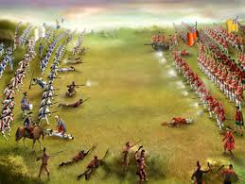
KEY CONCEPT: Conquest & Consquences
7.1.5: Students will assess, critically, the political competition between the French and the British in attempting to control North America by exploring and reflecting upon the following questions and issues:
7.1.5.1: In what ways did conflicts between the French and the British in Europe impact North America?
7.1.5.2: How did conflicts between the French and the British in Europe become factors in the Great Deportation of the Acadians in 1755?
7.1.5.3: To what extent was the Battle of the Plains of Abraham the key event in achieving British control over North America?
7.1.5.4: How was British North America impacted by rebellion in the 13 colonies and by the subsequent Loyalist migration?

Vocabulary: Use the glossary or text to define the following words.
Acadian | A francophone citizen of Acadia
Assimilation | Process by which a group or individual is absorbed in a more dominant culture because of its overwhelming influence.
Bias | A personal like or dislike of something that is not based on fact.
Bilingualism | Policy of recognizing two official languages
Deportation | An illegal citizen is kicked out the country they are residing in.
Fact | Information that is accepted as correct
Fortress | A military stronghold that often includes a town
Superpower | A country that is more powerful that almost all other countries
Neutral | A place or a country that does not want to pick sides
Siege | A blockade of a city
Opinion | A person’s thoughts or beliefs about something
Le Grand Derangement | Acadians sent to a distant land. They burned the villages

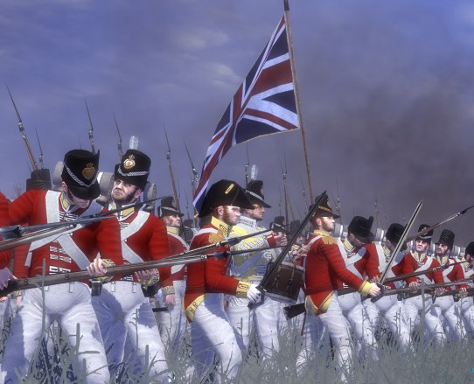
Chapter Inquiry - How did military events and their consequences contribute to the foundations of Canada?
Superpowers: In the 1700s, and
were rival . Both countries had , well-equipped and strong . Both were very and controlled large .
The French and English at War: and were often at war with each other. They both wanted more and the they contained, including those territories in North . Between 1690 and France and were almost at war.

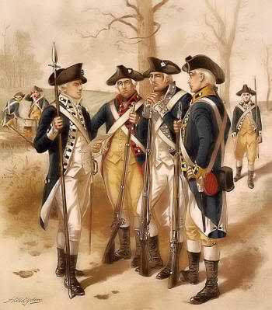
Background to War
The years war broke out in 1756. It was a war between the French and the English. Depending on who you talk to you will get a very perspective as to what happened.
The French were well established. There were about French colonists living along the River. By 1750 most of the population had been _____________ in New France. They felt very ________ because they were protected by __________________. New France supplied _____________. They had two might fortresses at _____________ & __________________.
The English in the Colonies far the French in New France. They needed more and wanted to trade with the First Nations in the . The English also wanted over the Atlantic which produced tonnes of fish which was sent back to to eat. The English also wanted to control the St. Lawrence which was the to the .

Use the chart below to list the strengths and weaknesses of the British and French.
British Strengths | French Strengths
British Weaknesses | French Weaknesses

War Rumblings in the West – The war for North America began in the River Valley in . British General was defeated by the French. So the British Prime Minister _________ promised to send more , and to fight the French.
PRELUDE TO WAR: ACADIA
Acadia had changed control times in the 17th century. First the captured it, then the French got it , and back and forth it went many times. By most of Acadia was under control. The Acadians lived under the British.
- Britain changed the French colony of name to
- Acadians still spoke and the British allowed them to their culture. The Acadians practiced the religion.
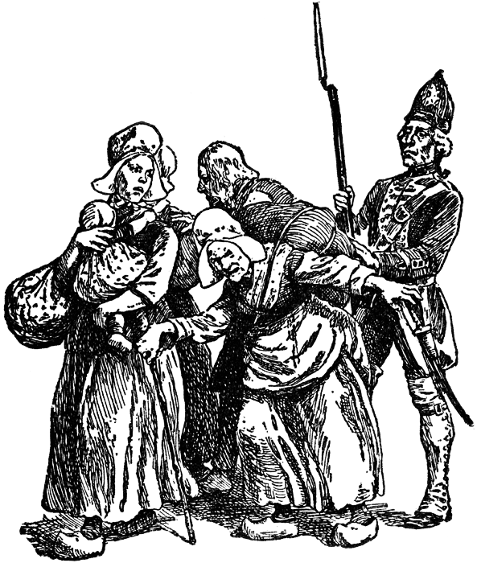
CAUGHT IN THE MIDDLE: Britain wanted to populate Nova Scotia with people who spoke . They were worried that the Acadians might take the of the . Because the Acadians had always to swear to the British . The Acadians were given an to swear loyalty or they would have their taken ___. Even though they wanted to remain and didn’t want to loose their land, the Acadians still to take the oath.
THE EXPULSION OF ACADIANS - LE GRAND DERANGEMENT
In Governor ordered that “the French inhabitants of the province of Nova shall be out of the country as soon as .” The British soldiers up the people at and put them on . They then their homes and and destroyed their .
Most of the Acadians ended up in the colonies. Some went to the , and . Some went into hiding and others ended up in , Louisiana. Many didn’t survive and of disease, or . In all about thousand Acadians were .
THE STRUGGLE FOR CANADA
England realized that in order to gain over New France it would have to ______ the fortresses of and .
Capturing Louisbourg - 1758 Louisbourg was and for weeks it was cut off from and and the French eventually .
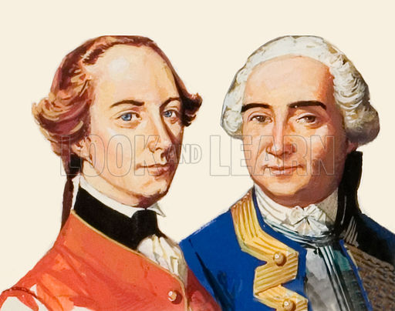
ONWARD TO CANADA: In 1759 under the leadership of General ______ the British sailed up the St. Lawrence River. He had ships, 9000 and sailors. For ____ months he fought against the Marquis de (French Commander) who had 16000 troops and a fortress that would not be easily.
POINTS OF VIEW BEFORE THE BATTLE:
WOLFE (British) | Montcalm (French)

A STANDOFF: The French and British bombarded each other for almost nine weeks, and winter was about to set in……

THE BATTLE OF THE PLAINS OF ABRAHAM:
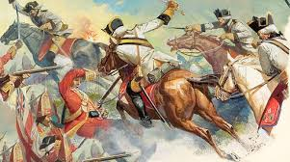
On 12 1759 General Wolfe decided to attack the French on the Plains of . They surprised the French by assembling there during the and when dawn broke they were in battle position just outside of the city . Moncalm lead his troops out to meet the British. Both Wolfe and were ___. After about 15 minutes the French retreated. The Battle on the Plains of Abraham is said to be the battle ever fought on soil. On September 8 the French surrendered at and New France passed into the hands.

THE LEGACY OF THE COLONY:
With their First Nation friends and allies, the Canadiens were able to accomplish a great deal over 150 years. What were some of these accomplishments?

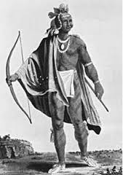
THE FIRST NATIONS AND THE WAR:

The First Nations were deeply in the wars between the and the .
REASONS FOR ANXIETY: Following the war, France and England made and a treaty in . This treaty gave England of most of North America. The First Nations people had been to take part in the peace process. Gradually the First Nations were their lands and they considered going to war against the British. Pontiac was a of the Odawa people and he convinced other First Nations to and drive the British out of the Ohio River . In May of 1763 he attacked the British fort at . The British eventually were able to them.

AFTER THE WAR
The , English and peoples would have to figure out a way to together in peace.
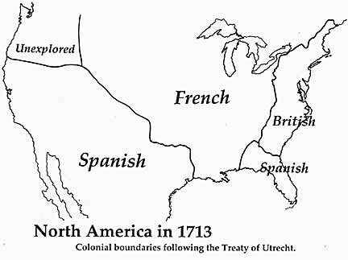
Treaty of Paris – In 1763, France and Britain signed the of which the conflict. This treaty meant that the French had to give up claim to and the French would get the producing island of in the . The only parts of New France that would still be under French control would be the tiny islands of Saint and off the coast of .
The British had gained control over what had been New France and now had to decide how to govern the colony. There options were: _________________, _________________ or _______________________
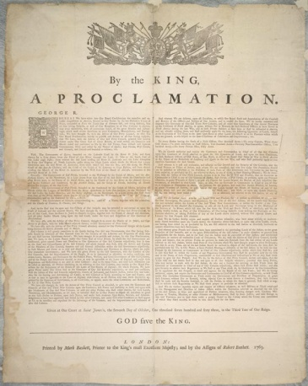
The Royal Proclamation of 1763
The British did not want to the Canadiens from their homes. However they did not want to them either. In October of 1763 King III of England signed a which stated the British plan for the colony.
Fill in the missing information as stated on the Royal Proclamation
- New France –
- The Province of Quebec became –
- The interior –
- French laws were replaced with –
- The military government was –
- This government consisted of –
- The Catholic Church –

The British realized that they had to pay attention to the of the First Nations People. The Royal Proclamation set aside a area of land for the . Europeans were allowed to live there.
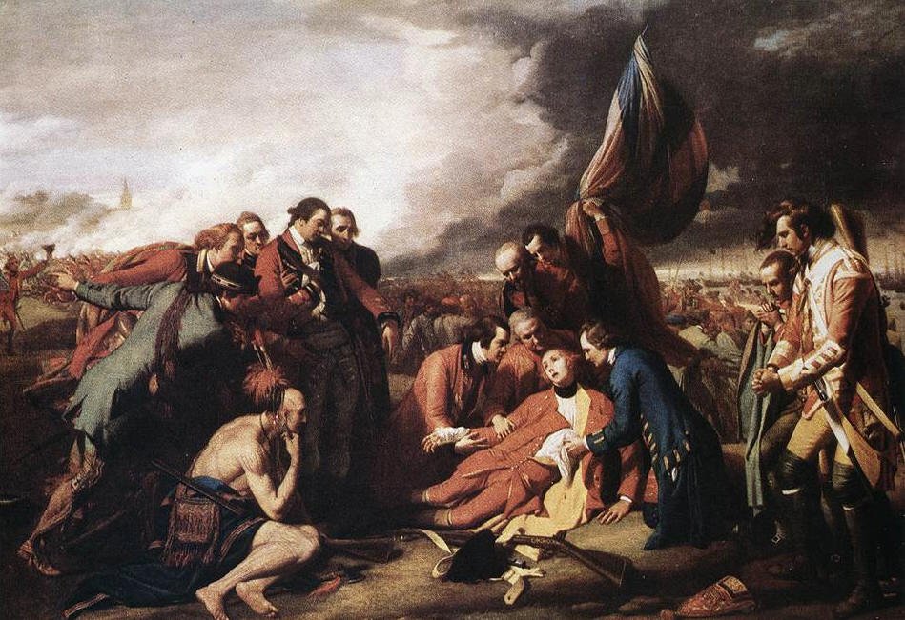
Quebec Act of 1774 – Trying to make Quebec into an colony failed because the French had a strong sense of .
The Quebec Act introduced which allowed for the official languages of and . They would have the right to government and do in either language. The British recognized the right to maintain their and .

Terms of the Quebec Act
- Quebec was –
- Aboriginal Lands were –
- French Language –
- The seigniorial system –
- Catholics –
- French civil law –
- The Roman Catholic Church -

