Name: ______________________

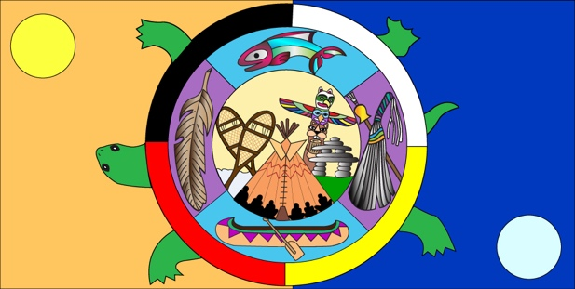
ABORIGINAL SOCIEITES:
Who are the diverse Aboriginal peoples who have contributed to the building of the country we now call Canada?

Chapter 1 (Pages 4-28)
Term & Definition | Example / Illustration
Culture:

Pluralistic Society:

Authentic:

Natural World:

Core Values:

World Views:

Traditional Teachings:

Elders:

Oral Culture:

Ethnocentric:

Clans:

Government:

Decision Making By Consensus:

Three Sisters:

Clan Mother:

Alliance:

Iroquois Confederacy:

Communal:

Economy:

