Grade 7 Social Studies Course Outline
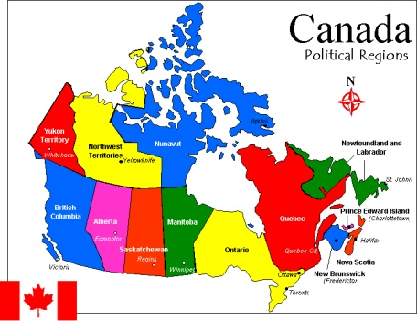
Social Studies provides opportunities for students to develop the attitudes, skills and knowledge that will enable them to become engaged, active, informed and responsible citizens.

The Grade 7 Social Studies curriculum consists of two sections:

Part 1: Canada Before Confederation
Students will study the events and people that have laid the foundations of Canada. As they discover how individuals and groups have had an impact on the history and developments of our country, students will develop an understanding of and appreciation for active citizenship.

Part 2: Canada After Confederation
Students will study the changes that have occurred in Canada since Confederation, including demographic, economic and social changes as well as governmental decisions. Students will further their understanding of an appreciation for active citizenship and how it has continued to shape Canada and the country’s pluralistic society.

Required Materials:
- Binder with lined paper & reinforcements
- Pencil Case with: pencils, erasers, highlighter, pen, scissors, glue stick, small ruler

Local and Current Affairs- In order to allow for students to engage in current affairs, issues and concerns of a local nature, the program of studies provides the flexibility to include the topics within the time allotted for social studies.

Grading Breakdown: Unit Exams & Major Projects = 60% and Quizzes and Minor Assignments = 40% of course work. Our final exam is worth 20% of the year’s mark.
Assignments/Projects: A rubric will be displayed and provided for the assignment with the specific criteria.
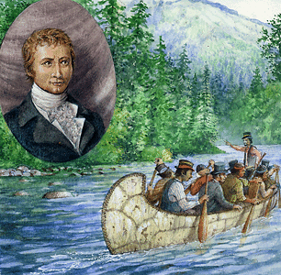
Unit Exams: A study guide will be provided one week prior to an exam. Answers can be viewed online a day or two before the exam as a last effort if students have lost their completed study guide.

What if my assignment or work is late? It is the expectation that all assignments will be completed to the best of each child’s ability and handed in on the set due date. On a hand in day, students will hand in and receive credit for what they have completed. If they require more time, they must come in and see me at lunch or after school. Late assignments are not allowed to be completed at home and brought in for a mark.

Communication - Communication with students and home is a vital part of my program. Please ensure that I have your e-mail address and that you have added yourself to Remind 101. Feel free to communicate with me at any time. If there are any concerns or questions, please contact me so that we can work together to make this a successful year for your child. Parents and students will be encouraged to view marks on PowerSchool to keep informed about grades and assignments.

Textbooks- I have a class set of textbooks in my class. If students want a personal hard copy, they may sign one out from the library. Alternatively, there is a digital copy available on my website with PDF chapters for download/printing.

Sincerely,

Miss Caitlin Mitchell

