A B C Autobiography

Name_________________________________

You will be writing an autobiography in the format of an alphabet book with vivid descriptions of things that matter to you.

Your autobiography must begin with a summary of basic information about yourself, or introduction. This may include things such as birthday, age, place of birth, family, etc. This introduction should be one paragraph in length (8-10 sentences).

For each letter of your name you are to write one paragraph that describes something about you. These may be:

- A favourite hobby
- A character trait that you have
- Something you have accomplished
- Places you’ve been
- People who are close to you
- Events you’ve attended
- Anything else that is part of your identity

Each letter page should also include a design, illustration or picture that adds to or depicts information in the paragraph.

**If your name is 4 letters or shorter you must include your middle and last initials as well!**

Please see the next page for an example of a completed planning page for an entry of Miss Mitchell’s autobiography.

PARAGRAPH PLANNING PAGE
ALPHABET Letter:
__M__ is for _Montana_

Topic Sentence | Miss Mitchell has grown up spending a lot of time in Montana.
★ Supporting Detail # 1  1. (sentence )  ⇨ Reasons, Facts, Details, Evidence, Examples, or Elaboration | - Montana is a state in the United States of America.  - It is directly under/south of Alberta.  - Lethbridge is only an hour to the Montana border.  - It has lots of mountains, trees, shopping and prairies.
★ Supporting Detail # 2  1. (sentence )  ⇨ Reasons, Facts, Details, Evidence, Examples, or Elaboration | - Miss Mitchell likes to be outdoors when she is in Montana.  - She has been swimming in the Flathead Lake, camping in Whitefish, and seafood in Helena.  - One time her brother accidently got a fish hook stuck in her hand (she still loves him though).
★ Supporting Detail # 3  1. (sentence )  ⇨ Reasons, Facts, Details, Evidence, Examples, or Elaboration | - She also has done A LOT of shopping in Montana.  - Her favourite places to shop are TJ Maxx, Ross, Herbergers, Marshalls, Hobby Lobby, Famous Footwear, and Barnes and Nobles.
Concluding Sentence | Miss Mitchell has done lots in Montana and always enjoys going down there for a getaway.

Final copy of paragraph:

Miss Mitchell has grown up spending a lot of time in Montana. Montana is a state in the United States of America. It is directly under/south of Alberta. Lethbridge is only an hour to the Montana border. It has lots of mountains, trees, shopping and prairies. Miss Mitchell likes to be outdoors when she is in Montana. She has been swimming in the Flathead Lake, camping in Whitefish, and went Sea-Dooing in Helena. One time, her brother accidently got a fish hook stuck in her hand (she still loves him though). She also has done A LOT of shopping in Montana. Her favourite places to shop are TJ Maxx, Ross, Herbergers, Marshalls, Hobby Lobby, Famous Footwear, and Barnes and Nobles. Miss Mitchell has done lots in Montana and always enjoys going down there for a getaway.
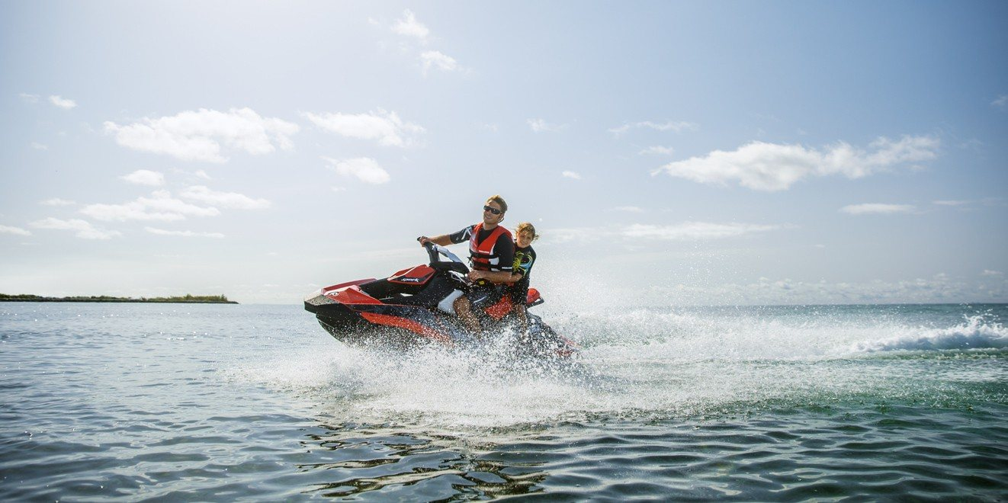

ABC Autobiography Check List

- Summary paragraph complete (5-7 sentences)
- Paragraph planning pages complete
- Two peers have read your work and edited for:
  - Capitalization
  - Punctuation
  - Does it make sense?
- Paragraphs written in final copy (or typed)
- Illustration, decoration or picture included for each entry

PARAGRAPH PLANNING PAGE
ALPHABET Letter:
______ is for _______________________

Topic Sentence

★ Supporting Detail # 1  1. (sentence )  ⇨ Reasons, Facts, Details, Evidence, Examples, or Elaboration | ⇨   ⇨ 
★ Supporting Detail # 2  1. (sentence )  ⇨ Reasons, Facts, Details, Evidence, Examples, or Elaboration | ⇨   ⇨
★ Supporting Detail # 3  1. (sentence )  ⇨ Reasons, Facts, Details, Evidence, Examples, or Elaboration | ⇨  ⇨
Concluding Sentence

Outcomes:

2.1.2: apply knowledge of organizational structures of oral, print and other media texts to assist with constructing and confirming meaning

2.1.6: use text features, such as charts, graphs and dictionaries, to enhance understanding of ideas and information

2.4.1: choose life themes encountered in reading, listening and viewing activities, and in own experiences, for creating oral, print and other media texts

3.4.2: select appropriate visuals, print and/or other media to inform and engage the audience

4.1.1: work collaboratively to revise and enhance oral, print and other media texts

4.1.2: ask for and evaluate the usefulness of feedback and assistance from peers

4.1.5: use paragraph structures in expository and narrative texts

(Daily 5) 2.2.3: make connections between own life and characters and ideas in oral, print and other media texts

(Daily 5) 2.2.7: summarize oral, print or other media texts, indicating the connections among events, characters and settings

(Daily 5) 2.3.3: discuss the connections among plot, setting and characters in oral, print and other media texts

(Daily 5) 4.2.7: edit for and correct commonly misspelled words in own writing, using spelling generalizations and the meaning and function of words in context

