Canada Expands: Chapters 9 and 10

Pg. 197: “Securing the Land” Discuss with your table partner.

Think about the word Secure. What images and meanings go with it? Is it the best word to use? What others words do you think could work? Why? What do you need in order to secure something?

SECURE

“A country is not a country without __________” After Confederation, a land rush was underway. Remember, at 1867 there were only _________ provinces: Nova Scotia, New ___________________, Ontario and ______________.

The government worked to gain control of the land we now see as part of our country before our southern neighbors, the _____________________ , could take control of it.

This meant they planned to reorganize how the land looked and would be used. The government worked to sign treaties with the various First Nations groups on the prairies and to mark the border with the United States.

The _______ parallel was chosen (a long time ago back after the war of 1812) as the border between ___________and the USA. With the help of Metis guides, American and British surveyors physically marked the border. Every _______ km, they planted an iron post. Every 5 km, they built a __________________.

Why did the Government create a police force? If Lethbridge didn’t have the police, would it be less safe? Why? How would problems be handled in your opinion?

The historical reason Canada created a police force was because of a massacre that happened in the Cypress Hills (land on the border now between Saskatchewan and Alberta)

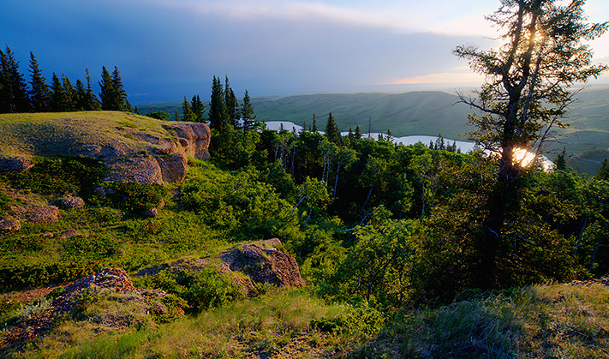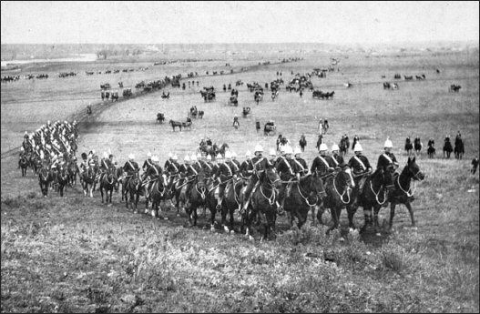

Without the presence of police and with the prohibition laws in the US (alcohol was illegal there), outlaws came up from Montana to trade liquor for furs. They also came to hunt wolves. The wolfers put poison in the dead buffalo carcasses the wolves would then eat and die. The pelts were then collected. Conflict occurred because, of course, other animals also ate the poisoned meat – like dogs that belonged to local First Nation groups.

P 198. As revenge, some First Nations would take the wolvers’ ____________. In the case of the Cypress Hills massacre, the Nakoda people had not taken the horses but they were blamed and attacked anyways. 36 men, women and children were murdered. The event made headlines back in Ottawa – it led to the creation of the _____________________________________, who were soon dispatched to head west and bring the rule of law to the west.

The Great March West p198-199

Wasn’t actually so great! What things went wrong?

Eventually there was a rescue. Who rescued them?

Finally they arrived at these two forts, one not far from Lethbridge.

The Role of the North West Mounted Police
Their job description included: p 199
- clearing out the _________________ traders
- arrested law breakers of all types
- delivered the ____________
- fought grass fires and helped new _____________
- fought in the second ______________ uprising.

Some little known laws that the police also had to enforce:
- attendance of children at the Indian Residential Schools was mandatory, police would arrest and jail families who didn’t comply
- leaving the reserve was illegal without permission from the Indian Agent. Police also enforced this.

Jerry Potts p201
Not just a road in Lethbridge! Named for this man! Read p 201 and jot down a minimum of 5 important things about him. Who was he? What did he do? Why did it matter?
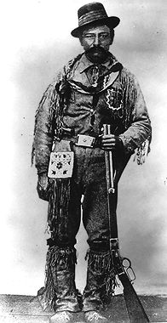

If the first part of the government plan was making the land safer, the second part was creating a way for settlers to actually travel west. And for this, they started to build the: (unscramble the anagram. Hint, 3 words )

aciCadafinancialyawRiP

National Policy – fill in the specifics of the National policy by writing three facts that give important information about what that part of the policy did.
Who, What, Where, Why, How, Why

National Policy p202
Transportation Policy | Immigration Policy | Economic Policy
 |  | p212 protective tariffs

The railway was incredibly expensive to build! For one kilometer for track, it cost half a million (19th century) dollars. For perspective, a house with 4 bedrooms cost $700.00….

Think of ways companies save money in making something? What strategy do a lot of companies use? Hint – where does the stapler come from?

The Canadian government exploited the use of Chinese workers in order to build the railway. Their argument was, “without the Chinese, there would be no railway” because it would be too expensive. Due to desperate conditions back in China, workers accepted wages that no white Canadian would accept.
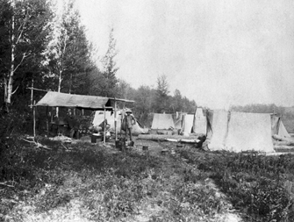
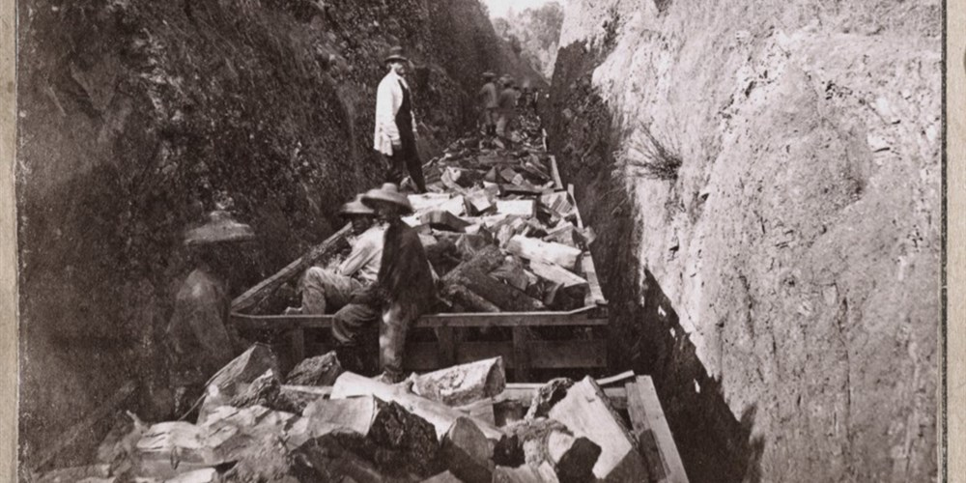
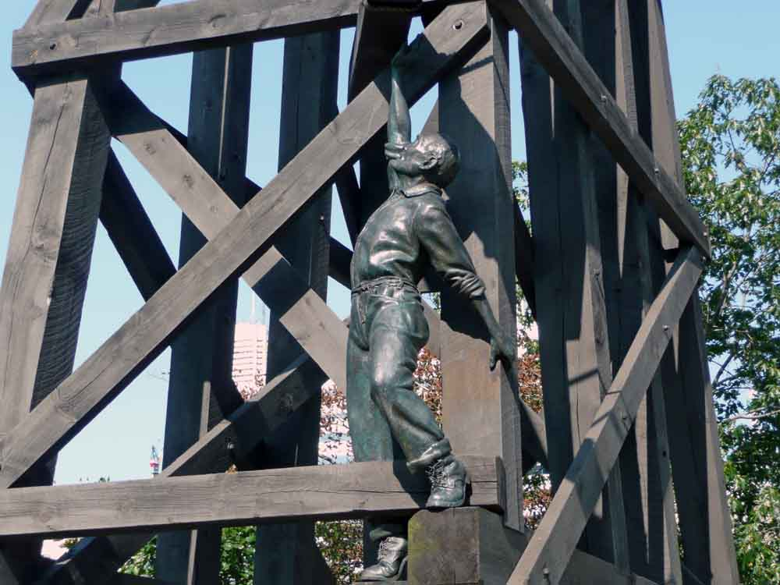

What can you infer from the photographs about the working conditions for the railway workers?

Read page 204 and the photo boxes on p 203 to find other dangerous/unfair working conditions. Is it any wonder people banded together to fight for the work conditions we enjoy today?

Impact p 203:

Over time, the railway brought many _______________. This changed the face of the ____________ forever. What does that mean?
With a way to get west, so many people came! Farming the land was the priority and in order to do this, Canada wanted to attract a lot of immigrants.

How was the land divided up? P 207

Before the homesteaders came, the government ____________ the land and divided into large _________ called ______________.
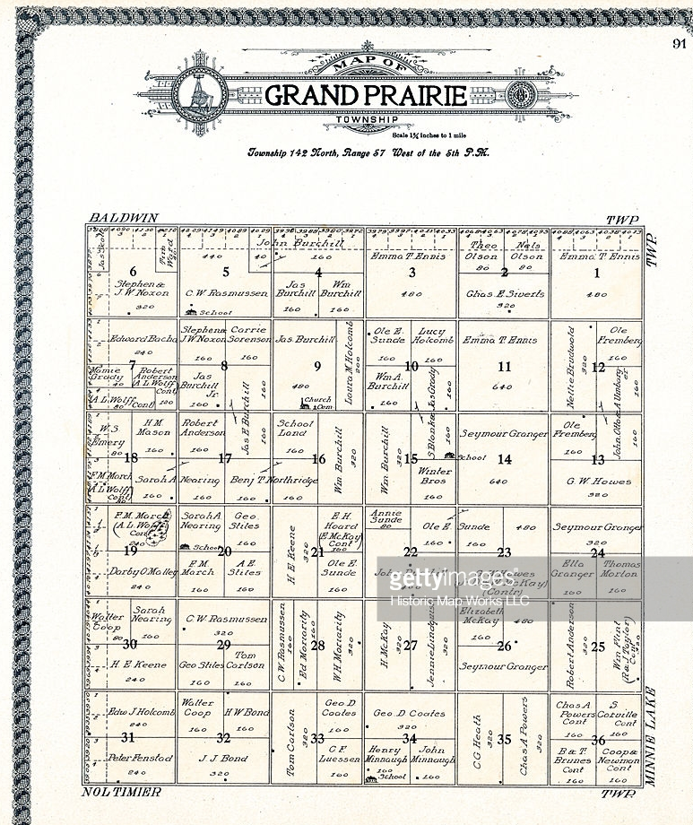
Each township was divided into ____ equal square sections and each section was divided into four ________ sections. This new way of organizing the land disrupted all the farms that were already established.

Dominion Lands Act p 208

In order to get a ¼ section of land, or a __________, you had to meet some criteria: circle the correct answer

1) Needed to be male female
2) Needed to be 21+ 18

And then you needed to fulfill some promises, or you’d have to give the land back. Homesteaders had just _______ years to make this happen! And for some it was like trying to spin straw into gold. #rumplestiltskin

- live on the land for at least……
- build a ……
- clear and prepare the land for ……

Many gave up in disgust. The life of a homesteading family was difficult. Most people were ______ and could not buy the materials needed to farm and build a house. Mother Nature was also cruel and in the years before crop insurance, people’s livelihoods were ruined sometimes by grasshoppers, lack of rain, early frost, or _______.

We’ll look at who specifically the government invited when we dive into immigration in chapter 11

Pg 211 As the land was sectioned off for farming, this meant a radical change for prairie First Nation groups. With the buffalo disappearing, some First Nations wanted to farm. There are several examples of Indigenous peoples farming – the Haudenosaunee, the Anishinabe at ______ _______ and farther west, the Nakoda and the __________.

When treaties were signed, the government _________ to help First Nations groups farm. They were supposed to receive land, as well as farm animals, _______ and seed as well as machinery and instructors to get them started.

However, many things stood in the way of success. P211
- most ______ given was not actually good for farming
- much of the equipment owed did not _________
- Instructors in a lot of cases, never arrived
- Often, First Nations farmers were _____________ from buying machinery.
- Finally those who did farm successfully, had a ______ time selling their crops.

As a result, many First Nations farmers ___________.

What role did racism play in these obstacles?

Notice the hand written PASS on page 211 –
What did Prairie Big Head get permission to do? From who?

Why would requiring a pass to leave the reserve make it harder to sell crops/produce?

What are some potential LONG TERM impacts of these types of policies? Hint: consider how this may negatively affect a community if they are prevented from running successful farms?

Provinces get added to CANADA

Review: The first four to join together and become Canada in 1867 were:
- 2.

3. 4.

And with Mrs. Maneschyn we saw the 5th province added in 1870, which was…..

5.

If we skip over the prairies and remember people had long been living in yet another British colony, ie British Columbia, we’ll meet out 6th province to be added. But first, what was going on in British Columbia a century ago?

The Northwest Passage’s Pacific entrance had been disproven by George Vancouver, James Cook had discovered some valuable sea otter pelt business but in the 1850s, everyone was rushing to British Columbia for…..

G O L D

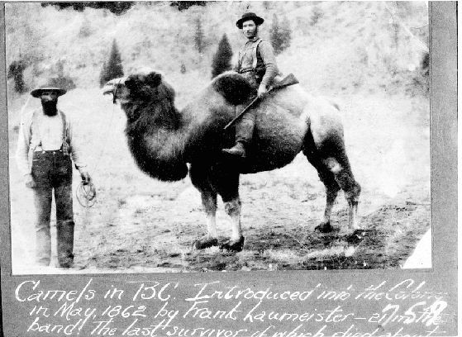
Thousands of prospectors came to BC. They discovered more gold along the Quesnel River in the Cariboo Mountains but it was hard to get there by river. Governor Douglas decided to build a wagon road. And get camels? Why do you think they thought camels would be a good idea?

Below is camel known as “the lady” she is the last surviving camel.

P223. The gold rush lasted only until 1868 – the newcomers stayed and built farms and businesses. Logging as an industry started. However, the colony found itself deeply in debt. There were not enough people to pay ______ or buy ______. With the Americans having purchased Alaska from the Russians in 1867, BC had to make a choice about their future.

They could: p224
1) Remain a …..
2) become a province of….
3) join the …..

They went to Ottawa to talk about possibly joining Canada. They made certain demands like Canada paying off their debts, wanting a road built across the prairies and receiving payments from Canada every year.

Canada agreed! And decided to build something better than a road. They build the ____________________.

On July 20 1871, British Columbia became the ____ province to join Canada.

Prince Edward Island FINALLY joins Canada!

PEI had been at the original talks about Confederation but had said no to joining.
But things were different now. England wanted to get rid of the colony and PEI feared American annexation.
Canada started to negotiate on some key points!
- Absentee Landowners – most of the land in PEI had been given to rich men who never actually lived there, instead they rented it to the people of PEI. The people couldn’t afford to buy it from these nobles. Canada offered to pay for it instead.
- Canada promised to build a railway across the island which was costing PEI a lot of money
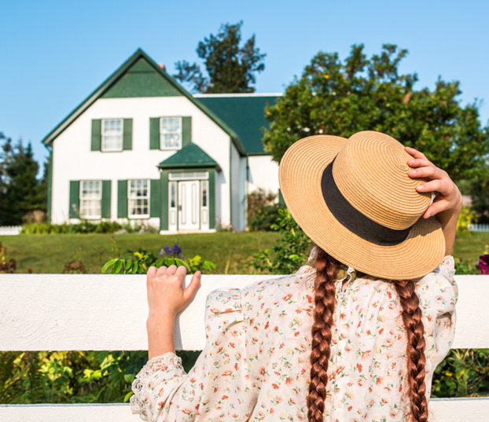
To sweeten the deal, Canada also promised to: (p228/229)

On July 1, 1873, PEI became the ______ province of Canada!
Saskatchewan and Alberta carved out of the North West Territories

Unlike British Columbia and PEI who were British colonies, Saskatchewan and Alberta were already belonging to Canada as part of the North West Territories. A territory has less power than a province. The North West territories wanted to be a province. But the Prime Minister, Sir Wilfred Laurier insisted the territories be divided into ____ provinces (p233). He argued that one province would be too ______ to manage and that it would be too ________. Imagine today if Alberta and Saskatchewan had joined forces!
Laurier ensured that in Saskatchewan and Alberta, that there would be a guarantee of a _________ school(235). English would still be the language of instruction, with one hour of _________ permitted.

In 1905, Saskatchewan and Alberta became Canada’s _______ and ______ provinces!

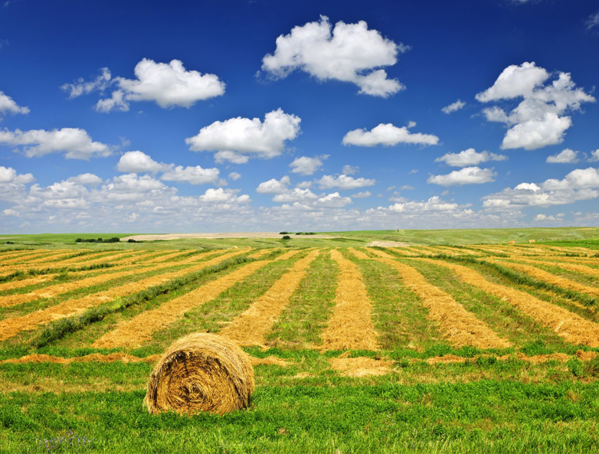

Newfoundland and Labrador Join!
It was many years before Newfoundland and Labrador would begin the process of joining Canada. The First and Second World Wars happened, the Great Depression happened and finally England told Newfoundland they needed to take back over control of their own affairs.

Many pro-confederation people said there were important benefits to joining Canada – like a stable economy and social services. Those against wanted Newfoundland to stay independent. They had two referendums about their future. After a close vote, it was decided.

On March 31, 1949, Newfoundland and Labrador became the ________ and final province (so far anyways!) of Canada.

