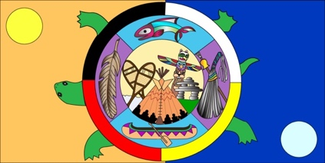
CHAPTER 1 STUDY GUIDE
Aboriginal Societies

REVIEW YOUR VOCABULARY SHEET

Answer the following questions on a lined paper

- Know the terms: First Nations, Aboriginal, Government.

- Why did some native groups follow a seasonal cycle and which clans practiced it?

- When a group reaches consensus, what do they do?

- What were the 3 main Native American groups we studied?

- What is a pluralistic society?

- What is the role of an elder in the Native culture?

- What is a Francophone?

- What is a stereotype?

- Why did the Haudenosaunee call beans, squash the Three Sisters?

- All First Nation groups had a close relationship with Mother Earth. What does this mean?

- Know the difference between matrilineal and patrilineal.

- What did the First Nations people do in their free time? Why didn’t they have a lot of time when food was scarce?

- What does the term hunter-gatherer refer to?

- What kinds of food did the Native tribes live on and what was the significance of “wild rice?”

- Native beliefs were passed on from generation to generation. How were these beliefs passed down? They were called __________________________________________ that helped to explain the relationships among plants, animals, land, people and the spirit world.

- Compare and Contrast the Haudenosaunee, Mi’kmaq and Anishinabe.

