Chapter 7: Creating a New Country
Name: _______________________
Chapter Inquiry – To what extent was Confederation an attempt to solve existing problems and lay a foundation for a country?
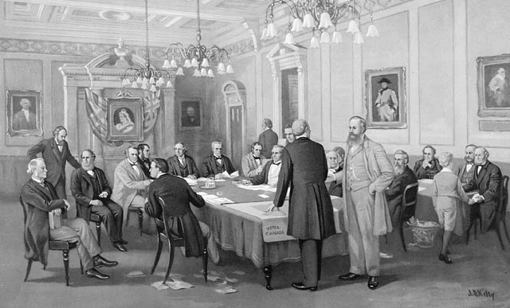

________________________________________________________________________________________________________________________________________________________________________________________________________________________________________________________________________________________________________________________________________________________________________________________________________________________________________________________________________________________________________________________________________________________________________________________________________________________________________________________________________________________________________________________________________________________________________________________________________________________________________________________________________________________________________________________________________________________

Vocabulary: Use the glossary to define the following words & terms.
Democracy
Representative Democracy
Responsible Government
Representation by Population
Manufacturing
Free Trade
Reciprocity Treaty
Manifest Destiny
Compromise
Consensus
Federalism (Federal System)

People and Government - Government is a way that organize themselves to make and get things done.

Canada’s Government
Canada is a REPRESENTATIVE democracy. This means that the PEOPLE hold the POWER by electing people to make DECISIONS or laws which are in the BEST interest for them. Canada has a RESPONSIBLE government which means that the Prime Minister’s cabinet must ANSWER to the elected REPRESENTATIVES.
Fill in the graphic organizer below with the appropriate information to explain how our Federal Government is organized:

Our current system of government began over 150 years ago. In the mid 1800’s the COLONIES of British North AMERICA began to think about JOINING together and the new government would have to be able to give each region a ) and meet the of the many different REGIONS.
This process was called CONFEDERATION!

Conditions for Confederation:
By 1858 there were seven colonies in British North America who were they?

What did all of these colonies have in common? THEY BEGAN TO WONDER IF THEY COULD BE STRONGER BY UNITING AS A SINGLE COUNTRY.

Political Deadlock in the Province of Canada:
By the 1850s the people where very UNHAPPY with the political system in the Province of CANADA. The single government assembly was mostly made up of ENGLISH speaking members. This meant that the FRENCH speaking Canadien MEMBERS were often outvoted on matters that were IMPORTANT to them. Because of this some Canadiens wanted to the province of Canada. During the 1850s the Assembly was by rivalries between the groups because no one could __________________ on anything.

- One of the issues that divided the Assembly was REPRESENTATION BY POPULATION. (this was not the system in Canada and it frustrated people)
- The Act of Union had given Canada East and Canada West the same NUMBER of seats in the Assembly.
- The fight over REP (representation) by POP (population) led to deadlocks in the Assembly and it was time for change.

Shifting Trade Partners:
problems were another reason that people wanted things to change. The system made Britain rich and helped the colonies do well because the colonies could _________ on Britain to buy their goods (because Britain placed a high tax on goods from other countries.)
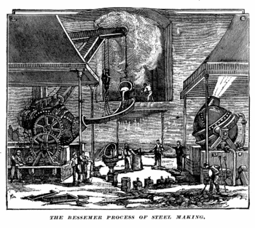
--------BUT THINGS CHANGED----
By 1846 the mercantile system no longer worked because Britain’s new MANUFACTURING industries were getting bigger and needed to find more places to sell its goods. Britain began FREE TRADE with all countries. This meant that the colonies no longer had a ASSURED market for their goods.

What did Britain do as a result of this? BRITIAN URGED ITS COLONIES TO LOOK FOR OTHER MARKETS TO TRADE WITH.
- The colonies began to with the United . In 1854 they signed a trade agreement. In this agreement , timber, and could be sold both ways without having any taxes.
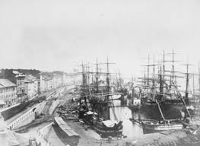
- Reciprocity Treaty: A TRADE AGREEMENT BETWEEN THE UNITED STATES AND CANADA BY WHICH NATURAL RESOURCES CAN FLOW BOTH WAYS ACROSS THE BORDER FREE OF ANY IMPORT TAXES
Why did business leaders have their own reasons for wanting a union of the colonies? IT WOULD GIVE BUSINESS IN CANADA EAST AND CANADA WEST

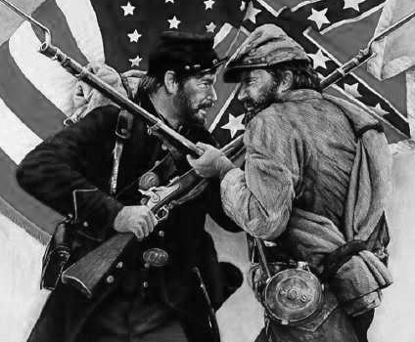
Defending British North America
In 1861 the American CIVIL war began between the SOUTHERN and the NOTHERN states. The main issues of this war were SLAVERY and the power that each state wanted to make their own LAWS . Eventually in 1865 the North WON the war. This concerned the colonists in Canada as they felt the Americans wanted to PUNISH Britain for supporting the south. Others believed in MANIFEST DESTINY.
- In UNION the colonies could PROTECT themselves better. It was one more reason to think about union.

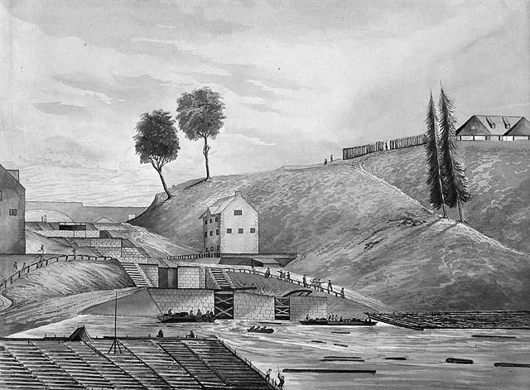
Choosing a Capital - Originally nobody could where the capital of Canada should be. Some believed that it would be best to share it between and Quebec city. In 1857 Queen was asked to the location for the new capital. She choose a small _________ town called which is now called . She decided this was a good location on the between Canada East (where the lived) and Canada (where the English lived). Because it was located at the place where three met it meant that people could get there . But it was far enough away from the US so they didn’t have to worry that the Americans would it. On December , 1857 it became the of Canada.

Confederation and the Maritime Colonies
The Maritime colonies had little in with the Province of Canada. They mostly made their from the sea. The goods which were shipped from their were all heading to , the United and the .
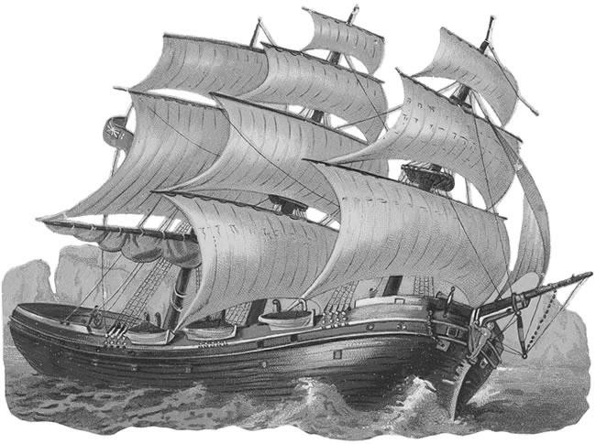
The Golden Age of the Maritimes - Between 1840 and 1870 it was a “GOLDEN Age” for the Maritime colonies. The shipbuilders were RESPECTED for the many, excellent wooden sailing ships they MADE. Nova Scotia was one of the LARGEST producers of coal in the World.
For many however, it was not a “Golden Age”. The Mi’kmaq and Maliseet first nations did not in the wealth. The Black experienced racism and . The workers in the lumber gangs experienced many .
Would Union Help or Hinder? Many people OPPOSED union because they thought it might END the good times. The people that were in favor of the union noticed that the world was CHANGING and the union would give them access to the bigger ECONOMIES of the Canadian Provinces. In time, supporters though, trade within the UNION would grow. They proposal of a railway was very ATTRACTIVE and would be good for business.
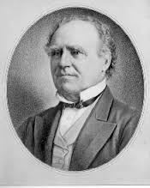
Write a short Biography of Joseph Howe
Born: 1804 Died: 1873
Biography:

- Leading politician in Nova Scotia during Confederation period.
- Spoke out against the government.
- In 1836 elected as leader of the Reform Party and helped bring Responsible Government to Nova Scotia.
Joseph Howe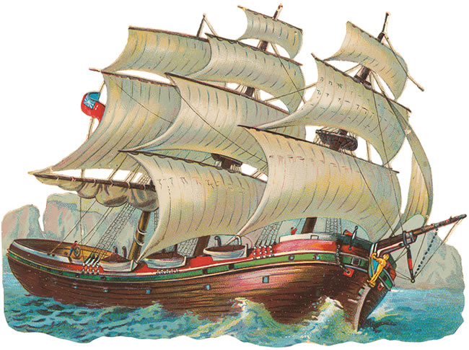
- Was NOT in favor of union. Spoke out AGAINST union with Canada.
- Believed Confederation favored Canada a the expense of the Maritimes.
Confederation Discussions
Breaking the Deadlock - In 1864 George who was the leader of the Clear , convinced his party to join a . They would vote with the Liberal- and Les and in return they would his plan to all of the colonies. Brown proposed federalism where each colony would have its own to run its own affairs. A central government would look after the that affected the union.
The Talks Heat Up - In 1864 delegates from New BRUNSWICK, Nova SCOTIA, and Prince EDWARD Island met in CHARLOTTETOWN then again they met in Quebec City. Eventually they came to a COMPROMISE where everyone would give up a little and they could reach a CONSENSUS. They drafted SEVENTY two resolutions where the FOUNDATIONS for a new country and government were established.

WHAT THE COLONIES DECIDED
– Explain what each of the colonies decided to do.
The Province of Canada

New Brunswick

Nova Scotia

Prince Edward Island

Newfoundland

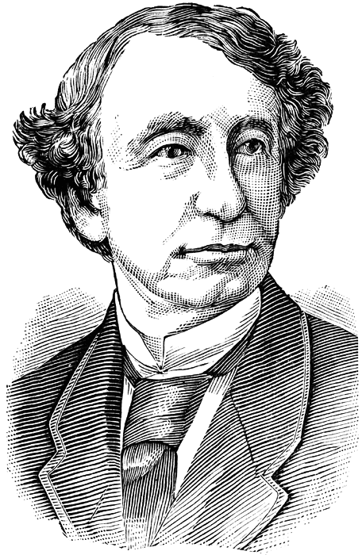
Working Together – Sir John A. Macdonald believed that the new Canada had to be a of the French Canadiens and the Canadians. To make this happen he formed an with George-Etiene from Canada East. At the London Conference of Macdonald was largely responsible for much of the British North America which is also known as the act.

Write a short Biography of George-Etienne Cartier

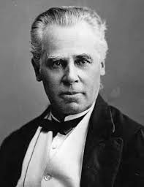
Born: 1814 Died: 1873
Biography: Was a Patriote
Quebec politician
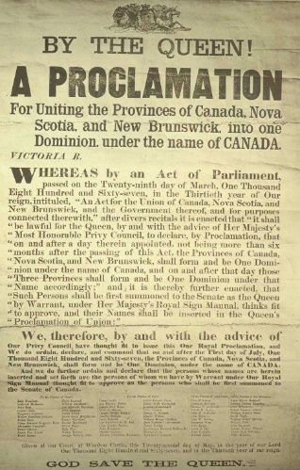
In FAVOR of Confederation (union of Canada)
George-Etienne Cartier
Worked together with Macdonald.
Adapted the French civil code.
Fought to achieve rights for Canadiens during Confederation.

At o’clock in the morning on 1st 1867 a from Queen was read aloud and the people celebrated creation of the new country of .

The Structure of Canadian Government
- Although the BNA Act proclaimed that Canada was now a COUNTRY the British still CONTROLLED the defense and foreign AFFAIRS. Canada would still remain a part of the British EMPIRE and the British Queen was Canada’s HEAD of STATE. A Governor GENERAL would represent the monarch (Queen) in Canada.
- The parliament would be made up of parts. An elected House of and an appointed (unelected) Senate. The number of in the House of Commons were based on by pop.
- The BNA Act called for a system of government. This resulted in two of government. The provinces wanted to keep their identities. The founders wanted to have a strong central . The federal government would have the power to make laws for the “ , order, and government: of Canada.

- What is residual power? ________________________________________
_____________________________________________________________

A Limited Democracy - In 1867 Canada was a democracy where only citizens over the age of 21 who owned or rented property were allowed to VOTE. Married women were NOT allowed to vote and very few SINGLE women owned any property. Farm LABORERS, unskilled WORKERS, First Nations Metis or INUIT people were also not allowed to VOTE. Today any citizen over the age of 18 is allowed to vote.

