Literary Analysis Hand In Assignment
Your task is to complete a literary analysis on Hair Love, the Darkest Dark, or the current FICTION book that you are reading. You are going to do this in the form of a ONE PAGER poster assignment that is a combination of WRITING as well as VISUALS. You must include the following:
Literary Element | Evidence
Setting | Where and when the story takes place with multiple lines showing this.
POV | The type with a line/quote from the story.
Conflict | The MAIN type of conflict in the story (person vs….?) along with a line or two from the story showing how you know this.
Plot | A FULL plot diagram with all 6 components labelled and explained.
Character | A S.T.E.A.L outline of the main character that has a line from the story for EACH of the elements.
Theme/Big Idea | TWO themes/big ideas from the text (one word each) with a complete sentence explaining WHY.

It is up to you how you would like to design and set up your page, as long as you have all of the elements and evidence above included. Be sure to include visuals that help explain and add to the elements and the textual evidence. This assignment sheet must be stapled to your one pager and handed in together.
Book Title: _____________________________ /22 marks
 | Exceptional | Meeting Expectations | Needs Improvement | Insufficient
Literary Elements /6 | All 6 literary elements were very clearly included in their entirety. | All 6 literary elements were included. | Some literary elements were included, but components were missing. | The inclusion of literary elements is insufficient and severely lacking.
Textual Evidence /12  (x2) | Textual evidence was extremely clear and thoroughly included for all elements. | Textual evidence was clear and included for the elements. | Some textual evidence was included, but there was lots missing. | The inclusion of textual evidence was extremely lacking and/or missing completely.
Visual and Written Communication /4 | The combination of both written and visual communication is thoughtful, intentional, and superbly executed. | The combination of both written and visual communication is well executed. | There could be much improvement in either the written or the visual (or both) communication. | The written and visual communication is severely lacking.
Literary Analysis: One Pager Examples
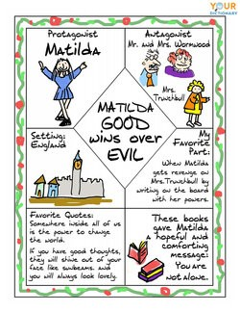
The following are examples of One Pagers.
The 5 elements of characterization can be explained with the acronym S.T.E.A.L.:
1) SPEAK = what (dialogue) and how (speaker tags & tone) a character speaks to other characters.
2) THOUGHTS = What a character thinks, believes, values, and what motivates a character.
3) EFFECTS on OTHERS = The relationships the character has with other others and how characters treat each other.
4) ACTIONS = How a character behaves, including how they react to people & events.
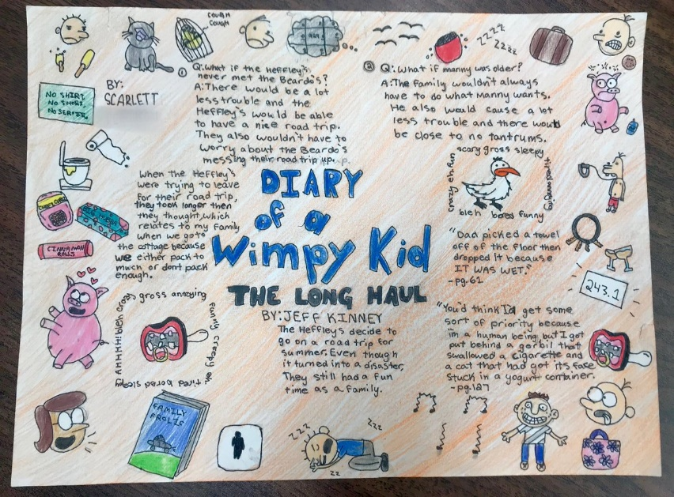
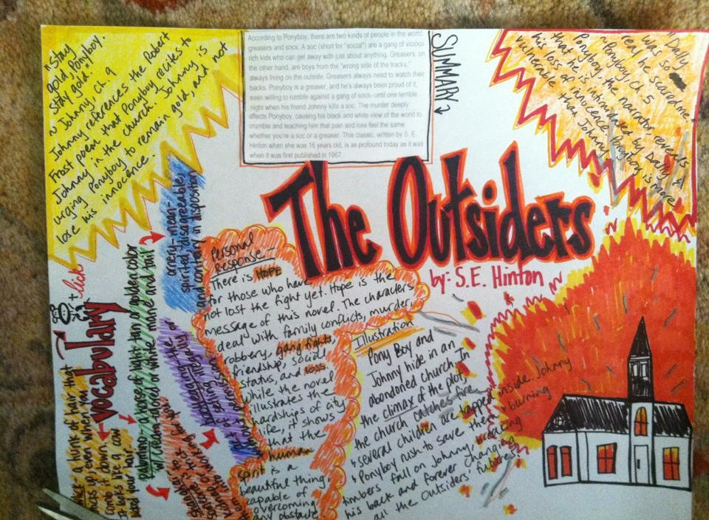
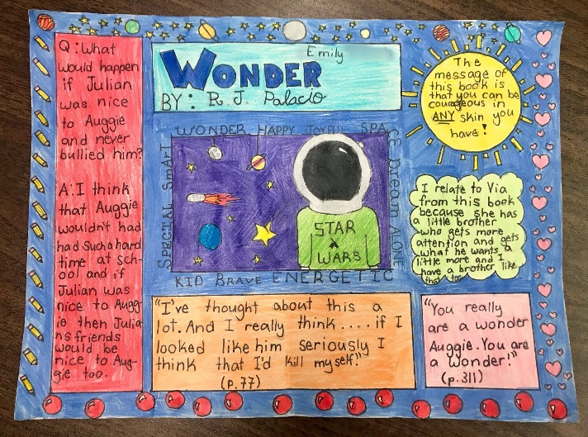
5) LOOKS = A character’s physical appearance. This includes physical features, clothing, body language, etc.

