Social Justice Book Club: Final Project
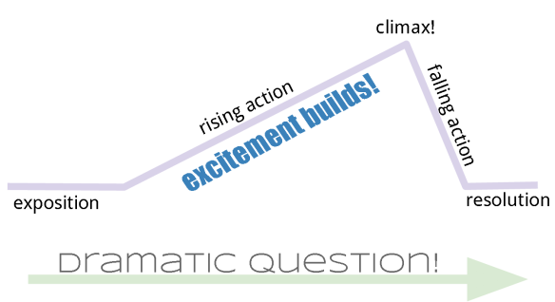
Directions: You will have a lot of choice in this project. It can be anything that catches your interest in terms of Social Justice. There are 2 parts to your final project. In order to receive full marks, you must have part 1 and 2 handed in. Here is what you must complete:
PART 1: You must complete a STORY ARC for your Social Justice book. Miss Mitchell will give you the handout for this assignment. Make sure you fill it out in detail, so that it is clear you read and understood your Social Justice book. Please use our “Literary Analysis” notes from October to help guide your thinking.
CONFLICT & CHARACTER GROWTH
PART 2: This is a STUDENT CHOICE section. You can pick to do any of the follow to show your understanding of the book you read or any Social Justice issue (past or present). Your options are as follows:
A) Book Report/Review
- If you want to do a classics book report and review this is for you.
- You will use this time to work through the theme, characters, setting, and give your own opinion on your book.
- You will ask your teacher for the handout that explains this assignment in detail
B) Fundraiser Pitch
- You are going to come up with a way to fundraise for a company that is fighting the injustices in our world today (ex. IJM)
- You must come up with a PITCH to your class (answering the 5 W’s and creating your proposal)
- You will ask your teacher for the handout that explains this assignment in detail
- The hope is that we can, as a class/DYAD, vote on one of the fundraising ideas and do fundraiser with the WHOLE school. We would donate everything fundraiser on behalf of our class at Wilson Middle School.

C) A Research Project
- What did you learn in your book that you would want to do some more research on and get more information?
- You are going to pick a topic (based on something from your book), complete a planning page or research (all websites sited), and create a short presentation with your information you discovered on the topic.
- You will ask your teacher for the handout that explains this assignment in detail
D) A PERSONAL Video
- I have really appreciated the vulnerability of Pranish as we have discussed really hard topics in our Social Justice unit. So….he has given me a great idea!
- You are going to do a personal video that looks a some sort of injustice within your life or family member.
- It is preferred that you video it and use a storytelling format for this project.
- You will ask your teacher for the handout that explains this assignment in detail
E) Other Ideas
- Any other project Idea that interests you (Teacher approval).
- You will have to fill out a handout as well that allows for your planning in whatever project you choose.
SOCIAL JUSTICE BOOK CLUB FINAL PROJECT RUBRIC: TOTAL: _____/30
Below Target  Areas that Need Improvement | Target Standard  for this Task | Above Target  Evidence of Exceeding Standards
Content (Ideas & Explores Topic)
Students ideas are thoughtful and sound. Student’s exploration of the topic is imaginative and logical. Student goes in-depth in their responses and shows many levels of thinking about different aspects of the topic. Student clearly communicates their thinking. _ _____/10
Mechanics & Planning Pages
Students have sound control of sentence structure, capitalization, punctuation, grammar, spelling & planning pages. ________ /10
Support
Student provides supporting details consistently (evidence & Specific examples for their chosen social justice topic). They are intentional & provide concrete support to the thoughts and ideas expressed. ______/10

